Retail Solutions – End-to-End Data Engineering Pipeline

1. Project Overview
ABC Retail Solutions is a multinational retail organization operating across multiple cities through both online and offline sales channels. The company collects transactional data from multiple source systems. However, inconsistencies such as duplicate records, missing values, inconsistent product naming, invalid quantities, varying date formats, and exposure of personally identifiable information (PII) affect the reliability of reporting and business analytics.
The objective of this project is to design and implement an end-to-end data engineering pipeline that ingests, cleans, transforms, validates, and aggregates retail transaction data to generate reliable business insights and interactive dashboards.

2. Problem Statement
The organization receives retail transaction data from two separate transactional systems:
- retail_data1
- retail_data2
Additionally, a reference dataset named product_details is provided for product validation and enrichment.
The project aims to:
- Integrate multiple retail datasets.
- Improve data quality through cleansing and validation.
- Standardize business data.
- Protect customer-sensitive information.
- Generate business KPIs.
- Build an interactive Power BI dashboard for decision-making.

3. Solution Architecture
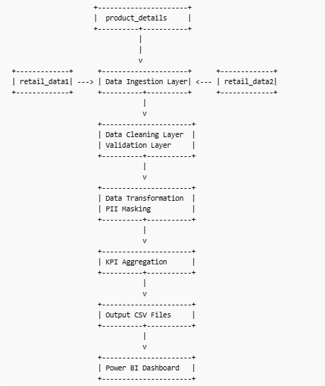

4. Data Flow Diagram

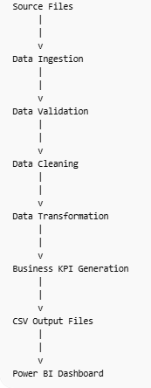

5. Data Model

Fact Table

cleaned_transactions
Contains all cleaned retail transactions.
Important attributes:
- transaction_id
- customer_id
- customer_name
- product_id
- product_name
- category
- city
- transaction_date
- quantity
- payment_method
- discount
- net_sales

Dimension Table

product_details
Contains product master information.
Attributes:
- product_id
- product_name
- category
- standard_price

6. Data Cleaning Strategy
Data quality improvement is one of the most important stages of the pipeline.

Duplicate Removal
Duplicate records were identified using:
transaction_id
and removed.
Missing Value Handling
Column | Action
discount | Replace with 0
city | Replace with Unknown
payment_status | Replace with Pending
purchase_location | Replace with Unknown

Invalid Quantity Removal
Records with:
quantity <= 0
were removed.

Date Standardization
Multiple date formats were converted into a standard datetime format.
Invalid dates were removed.

Product Standardization
Product names were standardized using:
- Trim whitespace
- Convert to title case
Example:
mobile phone became Mobile Phone

7. Data Governance and Security
Customer information must be protected before analytics processing.

Email Masking
Example:
Before:
johnsmith@gmail.com
After:
joh*****@gmail.com

Phone Number Masking
Before:
9876543210
After:
98******10

8. Transformation Logic
After cleaning, several business transformations were applied.

Revenue Calculation
Net Sales:
Net\ Sales=(Price\times Quantity)-Discount
This metric is used throughout the reporting layer.

Month Extraction
Transaction date was converted into:
YYYY-MM
for monthly trend analysis.

Product Enrichment
Transaction records were validated against the product master table.
This improves category consistency and reporting accuracy.

9. Visual Insights and Business Findings

9.1 Executive Summary Dashboard Insights
The Executive Summary dashboard provides a high-level overview of sales performance across the organization.

Total Revenue Analysis
The dashboard indicates that the company generated approximately:
₹1.06 Billion
in total revenue from retail transactions after data cleansing and transformation.
This demonstrates strong overall business performance across multiple cities and product categories.

Customer Base Analysis
The dashboard shows approximately:
2,000 Unique Customers
participating in retail transactions.
This indicates a broad customer base and healthy customer engagement across different regions.

Revenue Trend Analysis
The monthly revenue trend line reveals that:
- Revenue increased significantly during the middle months of 2025.
- Peak sales crossed ₹90 million in several months.
- Revenue declined sharply during early 2026 before stabilizing.
- The trend indicates possible seasonal demand fluctuations and changing purchasing behavior.
Business Implication:
Management can investigate peak-performing months to understand demand drivers and replicate successful sales strategies.

City-Wise Revenue Analysis
Revenue distribution across cities is relatively balanced.
City | Revenue
Chennai | ₹21.81 Crore
Hyderabad | ₹21.53 Crore
Bangalore | ₹20.92 Crore
Delhi | ₹20.88 Crore
Mumbai | ₹20.49 Crore
Insight:
No single city dominates sales, indicating a geographically diversified customer base and reduced dependency on a specific market.

Category Contribution Analysis
The category revenue chart indicates:
Category | Contribution
Home Appliances | Highest
Electronics | Second Highest
Furniture | Strong Contributor
Clothing | Moderate
Home | Moderate
Insight:
Home Appliances and Electronics together contribute a significant portion of total revenue, making them key revenue-generating categories.

9.2 Product Analytics Dashboard Insights
The Product Analytics dashboard evaluates product and category performance.
Product Performance
The donut chart shows that product sales are relatively evenly distributed among products.
Top-performing products include:
- Mixer Grinder
- Microwave
- Shoes
- Television
- Laptop
No individual product overwhelmingly dominates sales.
Insight:
The business has a diversified product portfolio, reducing dependence on a single product line.

Category Revenue Analysis
The category revenue bar chart reveals:
Category | Approximate Revenue
Electronics | ₹0.40 Billion
Electrical Products | ₹0.22 Billion
Furniture | ₹0.14 Billion
Home Appliances | ₹0.13 Billion
Home | ₹0.07 Billion
Insight:
Electronics is the strongest revenue-generating category and should remain a strategic focus area for inventory planning and marketing investments.

Discount Analysis
The discount distribution chart indicates:
- Electronics received the highest discounts.
- Home Appliances and Furniture also received significant discounts.
- Clothing and Home categories received relatively lower discounts.
Insight:
Higher discounts in Electronics may be driving increased sales volume and customer acquisition.
Management can analyze whether discount-driven sales are improving profitability.

Revenue Trend by Quarter
Quarter-wise analysis indicates:
- Q2 and Q3 of 2025 generated the highest revenue.
- Revenue contribution from 2026 is comparatively lower.
Insight:
The organization experienced stronger sales performance during 2025, suggesting either market growth or seasonal effects.

9.3 Customer Analytics Dashboard Insights
The Customer Analytics dashboard focuses on customer behavior and revenue contribution.

Customer Revenue Distribution
The customer revenue chart indicates:
- Most customers contribute moderate revenue levels.
- A small number of customers generate exceptionally high revenue.
Insight:
The customer base follows a common retail pattern where a small percentage of customers contribute a large percentage of revenue.
This suggests opportunities for:
- Loyalty programs
- Premium customer targeting
- Personalized marketing campaigns
Category-Wise Customer Distribution
Customer purchases are distributed almost equally across categories.
Categories include:
- Electronics
- Furniture
- Home Appliances
- Clothing
- Home
- Electrical Products
Insight:
Customers are purchasing products from multiple categories, indicating diversified buying behavior.

Data Quality Assessment
The data quality dashboard shows:
Metric | Value
Original Records | 8,494
Final Records | 6,283
Invalid Dates Removed | 1,631
Duplicates Removed | 494
Invalid Quantity Removed | 86
Missing Values Fixed | 0
Insight:
A significant number of records required cleansing before analytics could be performed.
Approximately:
26% of records
were removed due to quality issues.
This highlights the importance of implementing data validation rules at the source system level.

Category Revenue and Quantity Analysis
The summary table indicates:
Category | Revenue
Electronics | Highest Revenue
Home Appliances | Second Highest
Furniture | Third Highest
Additionally:
- Home Appliances recorded the highest quantity sold.
- Electronics generated the highest monetary value.
Insight:
While Home Appliances sell in larger volumes, Electronics generate greater revenue per transaction, indicating a higher average selling price.
10. Overall Business Conclusions
Based on the analysis, the following key findings were identified:

Finding 1
Electronics is the most profitable category and contributes the highest share of revenue.

Finding 2
Home Appliances demonstrate strong sales volume and consistent customer demand.

Finding 3
Revenue is well distributed across major cities, reducing regional business risk.

Finding 4
Customer spending follows a Pareto-style distribution where a smaller group of customers generates a significant portion of revenue.

Finding 5
More than 2,000 customers actively participated in transactions, demonstrating a healthy customer base.

Finding 6
Data quality improvements removed duplicate, invalid, and inconsistent records, resulting in a reliable dataset for decision-making.

Finding 7
The Power BI dashboard enables management to monitor revenue trends, customer behavior, product performance, and operational data quality through a single interactive reporting platform.
These insights align directly with the dashboards shown in your screenshots and will make your report look much more realistic and project-specific.
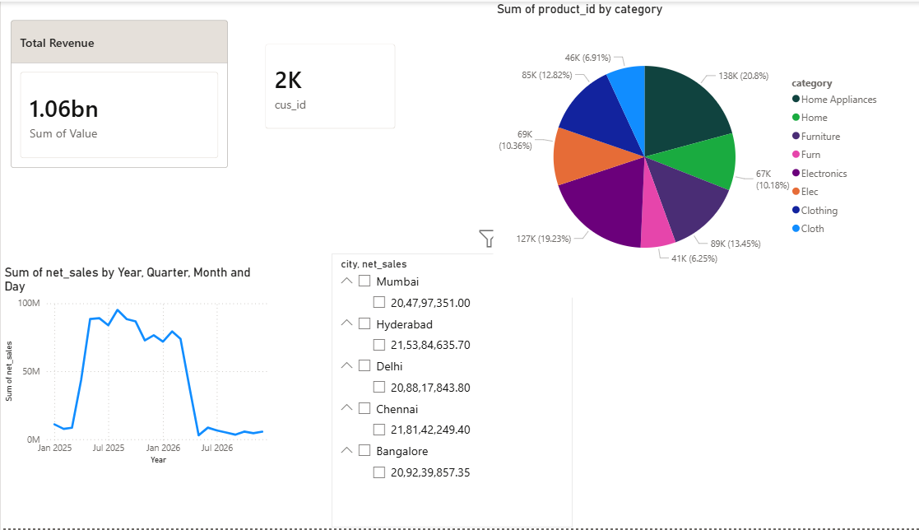
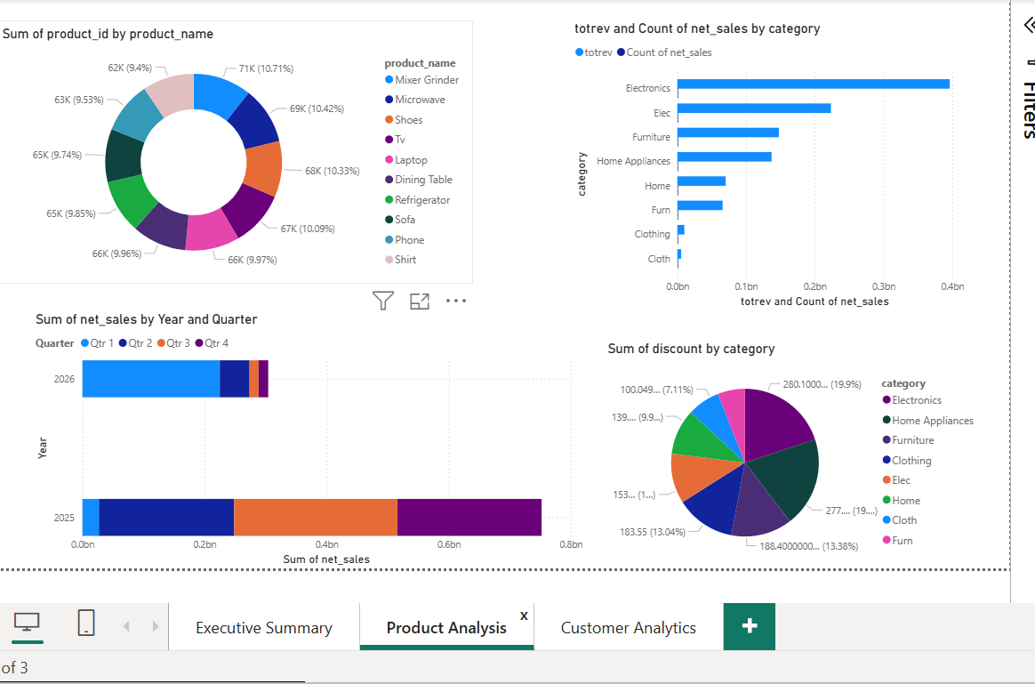
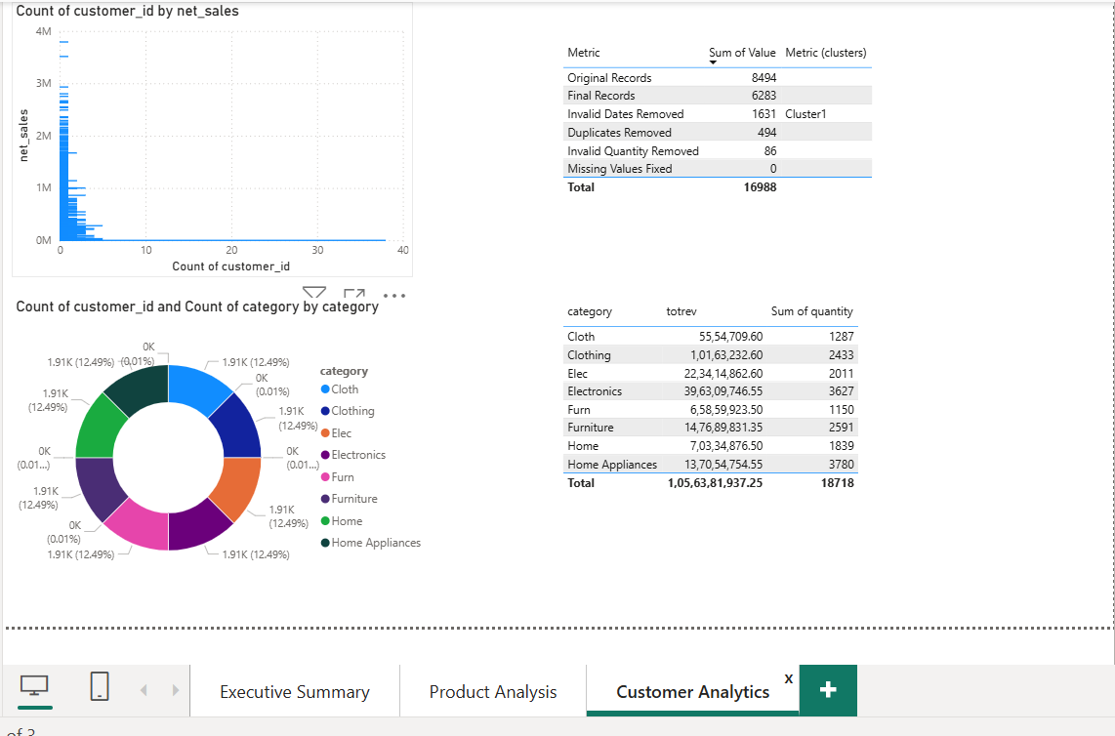

11. Scalability Considerations
The pipeline was designed to support future scalability.
Enhancements include:
- Migration to PySpark for large datasets.
- Integration with cloud platforms such as Azure Databricks, AWS Glue, or Microsoft Fabric.
- Automated scheduling using orchestration tools.
- Real-time data ingestion capabilities.
- Incremental data loading strategies.

12. Implementation:

Current implementation already covers:
✅ Data Ingestion
✅ Data Cleaning & Transformation
✅ Validation Rules
✅ PII Masking
✅ KPI Generation
✅ Logging
✅ Output Data Layer
✅ Power BI Dashboard

13. Future Cloud Implementation:
Although the solution was implemented locally using Python, Pandas, and Power BI Desktop, the architecture has been designed to be cloud-ready. In a production environment, the pipeline can be migrated to Microsoft Azure services such as Azure Data Factory for orchestration, Azure Data Lake Storage for data storage, Azure Databricks for scalable transformations, and Power BI Service for enterprise reporting and dashboard sharing.

14. Conclusion
This project successfully implemented an end-to-end data engineering pipeline for ABC Retail Solutions. Data from multiple source systems was ingested, cleansed, standardized, validated, and transformed into business-ready datasets. Customer-sensitive information was protected through masking techniques, and key performance indicators were generated to support business decision-making. The final Power BI dashboard provides interactive and actionable insights into revenue performance, customer behavior, product trends, payment preferences, and data quality, enabling data-driven decision-making across the organization.

